***Personal Finance Management System***

***Working Principle and Terminologies***

**Basic Terms**

1. SIP (Systematic Investment Plan): A method of investing a fixed amount regularly in a mutual fund scheme.
2. Step-Up SIP: A SIP where the investment amount increases at regular intervals to boost returns over time.
3. FD (fixed deposit): A savings scheme where money is deposited for a fixed tenure at a guaranteed interest rate usually 6%.
4. Small-cap fund: A mutual fund that invests primarily in companies with small market capitalization, typically high risk and high return. Usually gives an average of 18% annual return.
5. Large-cap fund: A mutual fund that invests primarily in large, well-established companies with stable returns and lower risk. Usually gives an average of 12% annual return.
6. Mid-cap fund: A mutual fund that invests on medium sized companies, balancing growth potential and moderate risk. Usually gives 15% annual return.
7. Future value of SIP: The estimated value of SIP investments at the end of a given period factoring in compound returns.

**Formula Used**

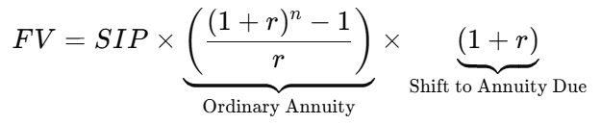

Here:

FV: Future Value

SIP: Initial amount

r: interest rate per period

n: number of periods

**Formula Break-Down**

* (1+r)n : Compound Growth Multiplier
  + Any money invested now will grow by this much after n months.
  + The first SIP payment will grow the most (for all n months), the second grows for n-1 months and so on.
* ((1+r)n – 1)/r
  + This piece calculates the future value of all equal monthly payments made at **end of each month** (ordinary annuity). It’s a sum of geometric progression.
* Multiplying ordinary annuity by annuity due (1+r)
  + Since payments in SIPs are made at the beginning of each month, each payment earns one extra month of interest compared to ordinary annuity.

In a Step-Up SIP, your monthly contribution increases every few months, so:

1. We can’t use a single formula across the whole duration.
2. Instead, we split the time into batches (where the SIP value is constant)
3. We apply the above formula to each batch separately, then sum up the results.